Sentimental Analysis – Base Code Result

Understanding Dataset – This Dataset consist of tweets and their sentiment result (Positive , Negative , Neutral )

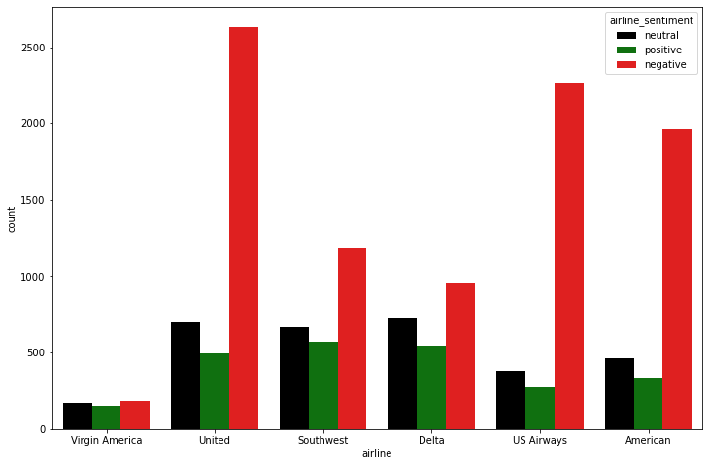

(i) Python liberary Used :

numpy

pandas

multiprocessing

nltk

matplotlib

seaborn

sklearn

(ii) Dataset link :

<https://www.kaggle.com/datasets/crowdflower/twitter-airline-sentiment/download>

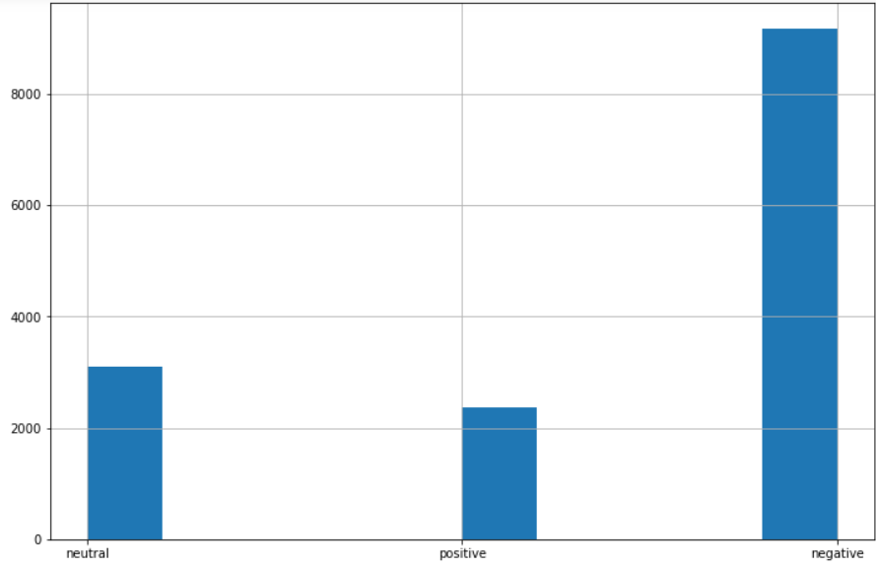

(iii) Preprocessing Technique Used :

Tokenising

Removing Stopword

Removing Punctuation

Removing word based on length

Stemming

Vectorisation

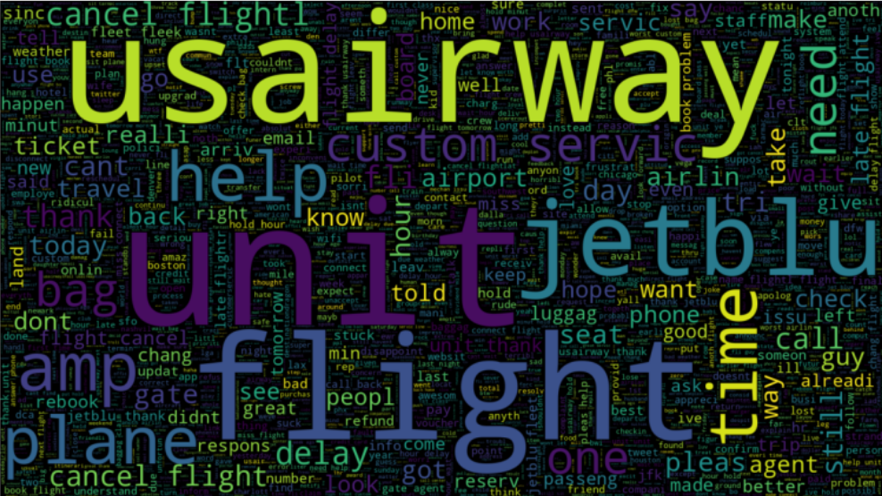

(iv) Models used :

(a) Naive bayes

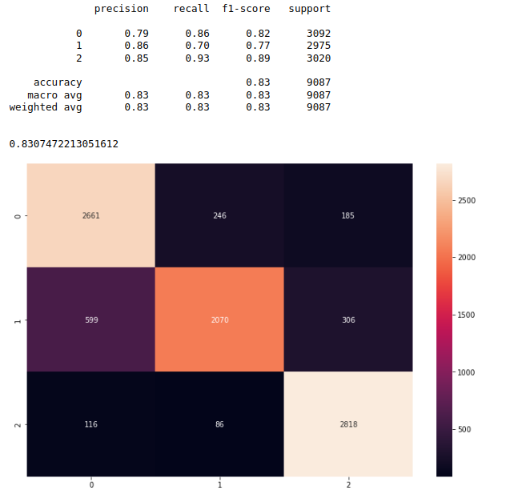

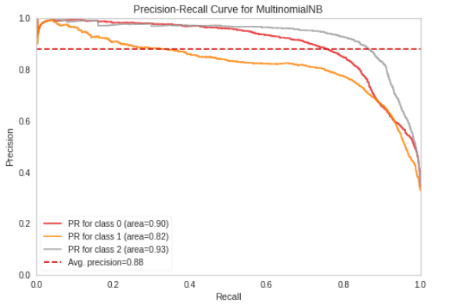

(b)Logestic regression

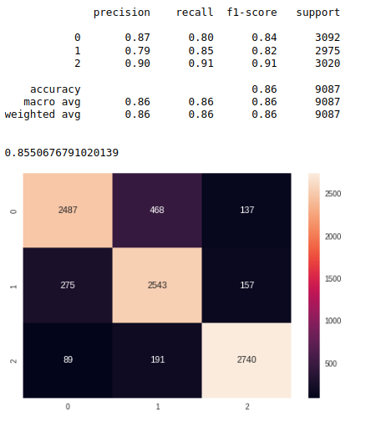

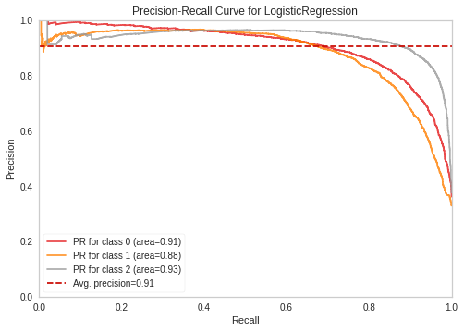

(c) Random Forest

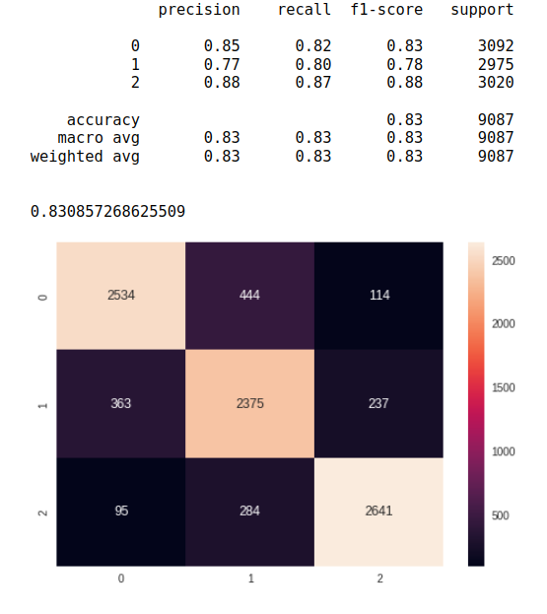

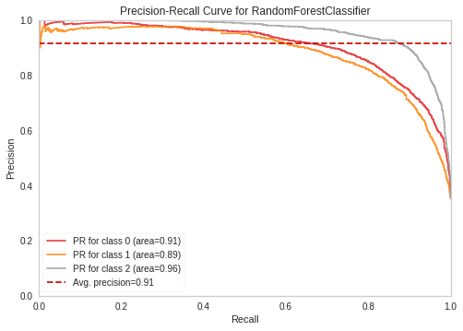

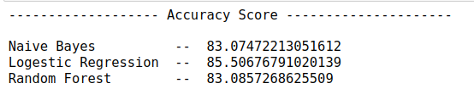(v) Accuracy Result